**Deepak Purohit**

**Program 4:**

Develop and demonstrate a HTML5 file that includes JavaScript script that uses functions for the following problems:

a. Parameter: A string

b. Output: The position in the string of the left-most vowel

c. Parameter: A number

d. Output: The number with its digits in the reverse order

<html>

<body>

<script type="text/javascript">

var str = prompt("Enter the Input","");

if(isNaN(str))

{

str = str.toUpperCase();

for(var i = 0; i < str.length; i++) {

var chr = str.charAt(i);

if(chr == 'A' || chr == 'E' || chr == 'I' || chr == 'O' || chr == 'U')break;

}

if( i < str.length )

alert("The position of the left most vowel is "+

(i+1)); else

alert("No vowel found in the entered string");

}

else

{

var num,rev=0,remainder;

num = parseInt(str);

while(num!=0) {

remainder = num%10;

num = parseInt(num/10);

rev = rev * 10 + remainder;

}

alert("Reverse of "+str+" is "+rev);

}

</script>

</body>

</html>

Output:-

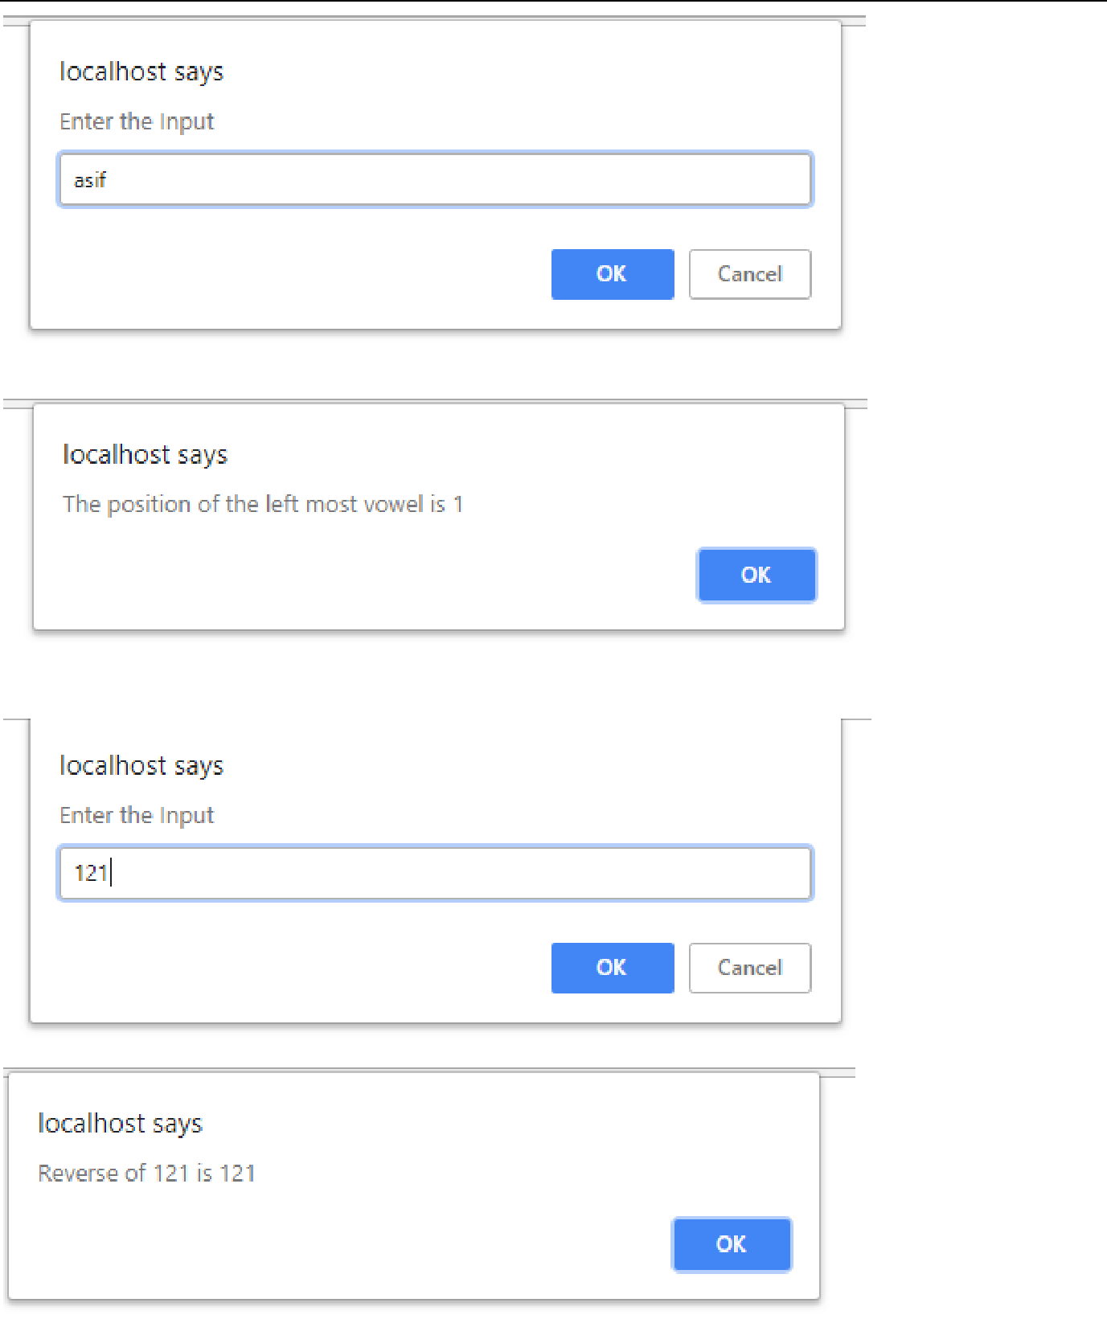

**Program 5:**

**Create a script that asks the user for a name, then greets the user with "Hello" and the user name on the page**

**Program**

<html>

<head>

<script type="text/javascript">

let name = prompt("What is your name?");

alert("Hello, " + name + "!");

</script>

</head>

</html>

**Output:**

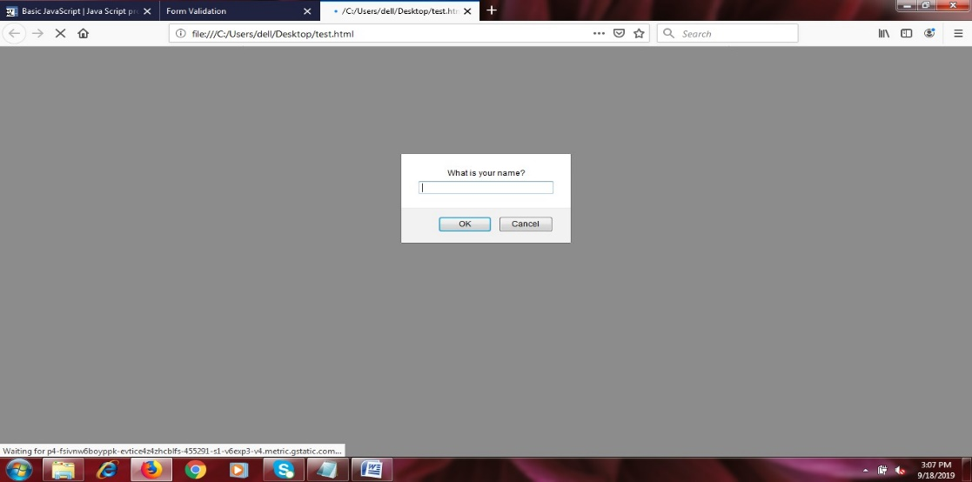

**Program 6:**

**Develop and demonstrate a XHTML file that includes Javascript script for the following problems:**

**a) Input: A number n obtained using prompt**

**Output: The first n Fibonacci numbers**

**b) Input: A number n obtained using prompt**

**Output: A table of numbers from 1 to n and their squares using alert**

**(a)**

<?xml version="1.0" encoding="utf-8"?>

<html xmlns="http://www.w3.org/1999/xhtml/">

<head><title>Fibonacci Series</title>

</head>

<body bgcolor="yellow">

<h3 style="text-align:center;color:red"> Program to generate first n fibonacci numbers </h3>

<script type="text/javascript">

var limit = prompt("Enter the number");

var f1=0;

var f2=1;

document.write("<h3>The limit entered is: </h3>",limit,"<br/>"); document.write("<h3>The fibonacci series is: </h3> <br/>"); if(limit == 1)

{

document.write("",f1,"<br/>");

}

if(limit == 2)

{ document.write("",f1,"<br/>"); document.write("",f2,"<br/>");

}

if(limit > 2)

{ document.write("",f1,"<br/>"); document.write("",f2,"<br/>"); for(i=2;i<limit;i++)

{

f3 = f2+f1; document.write("",f3,"<br/>"); f1=f2;

f2=f3;

}

}

</script>

</body>

</html>

**Output:**

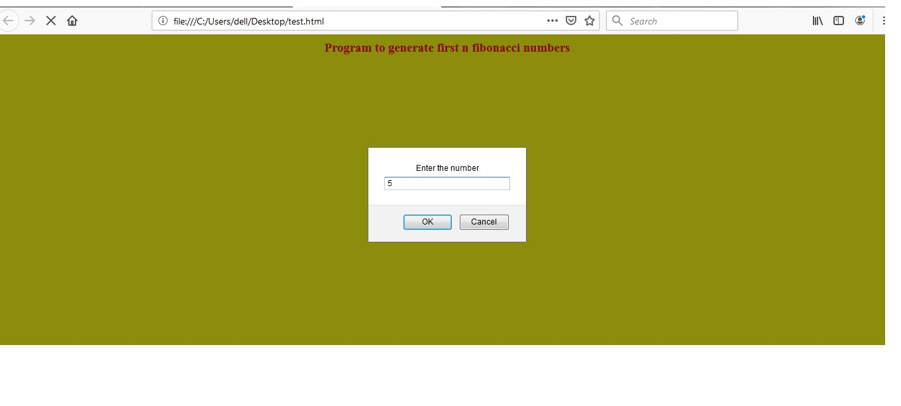

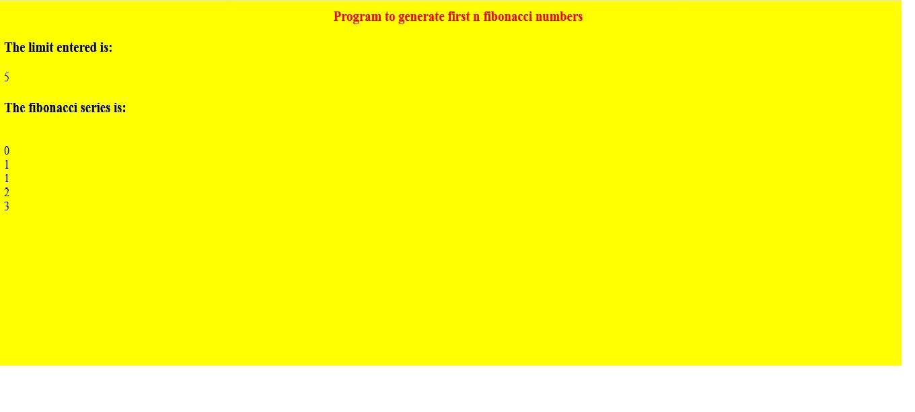

**(b)**

<?xml version ="1.0" encoding = "utf-8?>

<html xmlns="http://www.w3.org/1999/xhtml">

<head>

<title> square.html </title>

</head>

<body style="background-color:yellow">

<h3 style="text-align:center;color:red"> Program to generate a table of numbers from 1 to n and their squares using alert</h3>

<script type="text/javascript" >

var n= prompt("Enter the limit 'n' to generate the table of numbers from 1 to n:","");

var msg = "";

var res = "0";

for(var x = 1; x <= n; x++)

{

res = x * x;

msg = msg + " "+ x + " * "+ x + " = " + res + "\n";

}

alert(msg);

</script>

</body>

</html>

**Output:**

